  Application form (music)  Please complete this form in blue or black ink. | 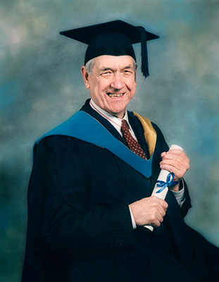

Name

Address
Telephone numbers
Home
Mobile

Email address

Name and purpose of group

Outline of proposed project

Outline of benefit to individual or group

Details of likely costs involved

Information on group’s contribution to this project, if any

Have other grants been applied for this project? Please give details.

How many young people will benefit from any assistance?

Any additional information in support of your application

Please provide a referee and contact details

If you wish to submit further information, please feel free to attach extra sheets. Some information may be held electronically for admin purposes, but will not be divulged to outside parties. Please sign below to say you understand this and give permission for it.

Your signature | Date

Please return this form to
Mr S Macgregor, Reid and Fraser CA, 15 Princes St, Thurso, KW14 7BQ
Applications will be considered at any time.

